​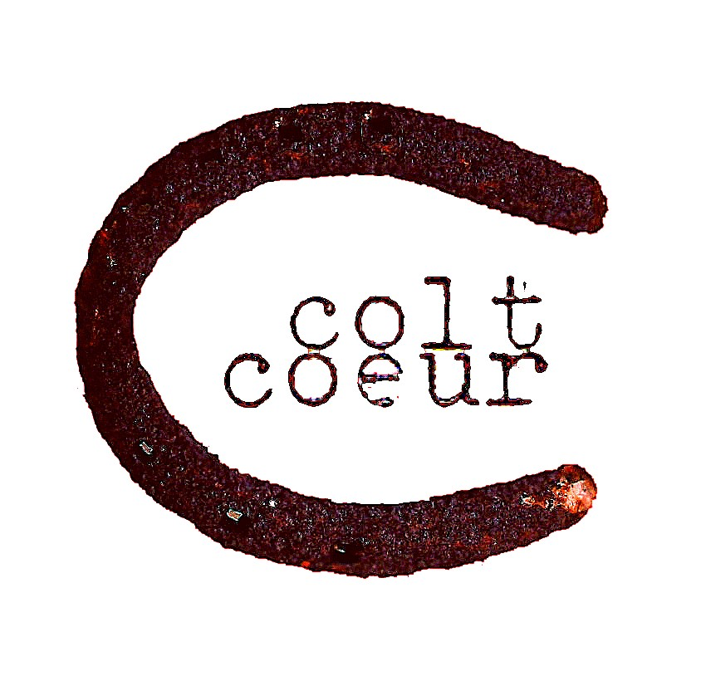
Colt Coeur’s FREE Theatre Workshop
for Brooklyn public school students ages 10-15
​ April 2-6, 2018 10am-2pm (12pm-8pm on Friday, April 6th)
Performance: April 6th, 2018 6:30pm
Application
- Name: Age:
- Student cell AND email:
- Parent's name & signature:
- Parent cell AND email:
- Home address & neighborhood where you live:
- School name & grade:
- Contact name AND email for teacher or guidance counselor​:
- ​Please describe a theatrical event you attended recently (at school/ church/ Broadway/ parade/etc.) What was your favorite part of the experience?
- ​What areas of theatre interest you most? (Writing? Acting? Directing? Design?) Why?
- ​Who is your favorite character from a book, play or movie? Why?​
Students MUST attend all five days of the program in order to enroll. By submitting this application you are confirming your attendance at all 5 days of the program. Submit this application by March 20th.
Please email this document to coltcoeur@gmail.com or mail it to Colt Coeur, 138 South Oxford Street, Suite 4E Brooklyn, NY 11217. Contact Adrienne at 646.489.7380 if you have questions or concerns. You will be notified by March 18th with additional information.

